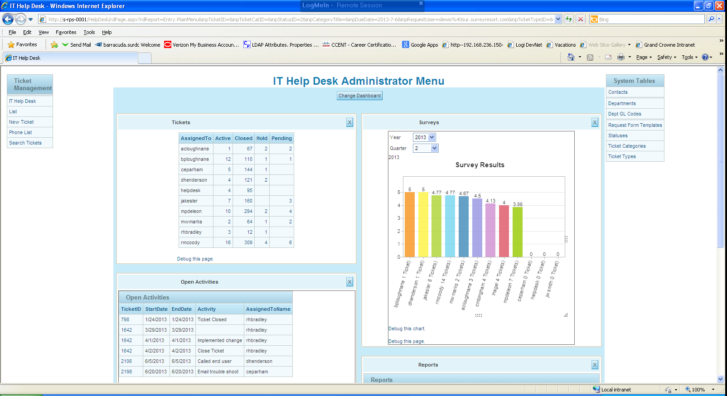
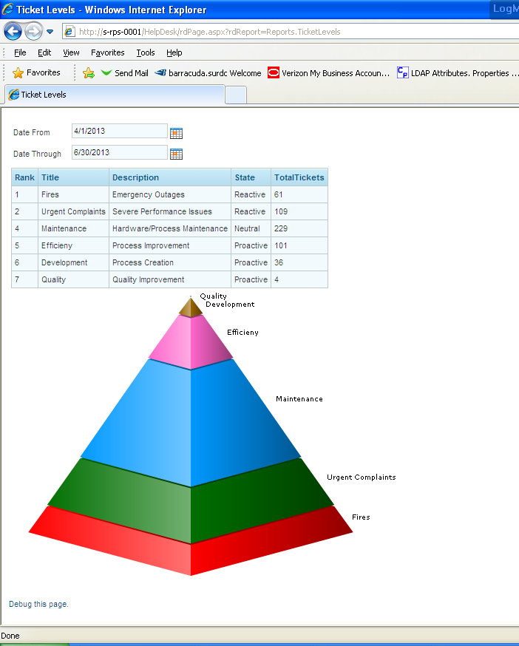

USE [HelpDesk]
GO
/****** Object: StoredProcedure [dbo].[sp_AddEditTickets] Script Date: 06/23/2013 12:24:22 ******/
SET ANSI_NULLS ON
GO
SET QUOTED_IDENTIFIER ON
GO
-- =============================================
-- Author: Alicia Loughnane
-- Create date: 11/2/2011
-- Description: AddEditTickets
-- =============================================
CREATE PROCEDURE [dbo].[sp_AddEditTickets] (@inpTicketID int, @inpTicketType int, @inpTicketCategoryID int, @inpStatusID int,@inpPriority varchar(25), @inpDueDate Datetime, @inpRequestUser varchar(50),@inpPhone varchar(15,@inpAssignedTo varchar(50), @inpBillTo varchar(50), @inpLinkID int, @inpAddDescription varchar(max,@inpEditDescription varchar(max),@inpSolution varchar(max), @inpInternalNotes varchar(max,@inpHostName varchar(30), @inpKnowledgeBase bit, @inpQuotes bit, @inpCreateBy varchar(50,@inpCloseDate datetime, @outTicketID int Output)

AS
BEGIN
-- SET NOCOUNT ON added to prevent extra result sets from
-- interfering with SELECT statements.
SET NOCOUNT ON;
--ERROR HANDLING ************************************************************************
IF isnull(@inpBillTo,'') =''
Begin
Raiserror('You must select a Department.',11,1)
Return
End

IF isnull(@inpTicketCategoryID,'0') ='0'
Begin
Raiserror('You must select a category.',11,1)
Return
End

IF isnull(@inpTicketType,'0') ='0'
Begin
Raiserror('You must select a Ticket Type',11,1)
Return
End

IF isnull(@inpRequestUser,'0') ='0'
Begin
Raiserror('You must select a Requesting User',11,1)
Return
End
--***************************************************************************************

Set @inpAssignedTo = CASE WHEN ISNULL(@inpAssignedTo,'') = ''
THEN 'helpdesk@sur.surreyresort.com'
ELSE @inpAssignedTo
END
Set @inpRequestUser = CASE WHEN CHARINDEX('@',@inpRequestUser)= 0
THEN 'helpdesk@sur.surreyresort.com'
ELSE @inpRequestUser
END -- This catches a blank or incorrect request
-- user and routes it back to the helpdesk email.

Declare @inpDepartmentID int = isnull((Select DeptID
from Departments
Where DeptDesc = @inpBillTo),41) --use 'Need to Assign' Dept ID

--Declare variables for email notifications
Declare @inpFrom varchar(100) = 'helpdesk@grandcrowneresorts.com'
Declare @inpTo varchar(100) = (Select(Left(@inpAssignedTo,
Charindex('@',@inpAssignedTo) - 1) + '@grandcrowneresorts.com'))
Declare @inpReqUser varchar(100) = Replace((Select(Left(@inpRequestUser, Charindex('@',@inpRequestUser) - 1) + '@grandcrowneresorts.com')),'1','')
Declare @inpSubject varchar(50) = ' '
Declare @inpBody varchar(max) = 'http://s-rps-0001/HelpDesk/rdPage.aspx?rdReport= Entry.SearchTickets&inpLookup=' + Cast(@inpTicketID as varchar(10)) + space (20)+ 'Ticket Description: ' +'
'+ isnull(@inpEditDescription,' ')
Declare @inpEMail varchar(50) = (Select eMail From Departments Where DeptID = @inpDepartmentID)

IF isnull(@inpTicketID,0) = 0 --ADD
BEGIN
insert into Tickets (TicketTypeID, TicketCatID, StatusID, Priority,DueDate, RequestUser, Phone, HostName, AssignedTo, BillTo, LinkID, [Description], Solution, InternalNotes, KnowledgeBase, Quotes, CloseDate,CreateBy,CreateDate)

values (@inpTicketType, @inpTicketCategoryID, 2, @inpPriority, @inpDueDate, @inpRequestUser, @inpPhone, @inpHostName,@inpAssignedTo, @inpDepartmentID, @inpLinkID, @inpAddDescription, Replace(@inpSolution,'&','and'), Replace(@inpInternalNotes,'&',' and '),@inpKnowledgeBase, @inpQuotes, @inpCloseDate, @inpCreateBy, Getdate())

Set @outTicketID = @@IDENTITY

Insert into TicketHistory(TicketID, AED, EventDateTime, CreatedBy, AssignedTo, StatusID, Priority, DueDate)

(Select TicketID,'A',GETDATE(),@inpCreateBy,@inpAssignedTo,StatusID,Priority,DueDate
From Tickets
Where TicketID = @outTicketID)

--Notify Agent that a new ticket has been submitted

Set @inpSubject = 'Ticket # ' + Cast(@outTicketID as varchar(5)) + ' has been submitted to ' +
Case When Left(@inpAssignedTo,Charindex('@',@inpAssignedTo) - 1) = 'HelpDesk'
Then 'the ' + Left(@inpAssignedTo,
Charindex('@',@inpAssignedTo) - 1)
Else Left(@inpAssignedTo,Charindex('@',@inpAssignedTo) - 1) End
Set @inpBody = 'http://s-rps-0001/HelpDesk/rdPage.aspx?rdReport= Entry.SearchTickets&inpLookup='
+ Cast(@outTicketID as varchar(10)) +
'
' + isnull(@inpAddDescription,' ')

exec master.dbo.sp_SQLNotify @inpFrom,@inpTo,@inpSubject,@inpBody
insert into TicketMessages (MessageType,[Message],SendDate,SendTo,SendFrom,TicketID)
Values('eMail New Ticket sent to helpdesk',@inpSubject,GETDATE(),@inpTo,@inpFrom,@outTicketID)

--Notify eMail Contact that a new ticket has been submitted by an employee
IF ISNULL(@inpEMail,'0') <> '0'
Begin
Set @inpSubject = 'Ticket # ' + Cast(@outTicketID as varchar(5)) + ' has been submitted to IT.'
Set @inpBody = 'http://s-rps-0001/HelpDesk/rdPage.aspx?rdReport=Entry.SearchTickets&inpLookup=' + Cast(@outTicketID as varchar(10)) +'
'+ isnull(@inpAddDescription,' ')

exec master.dbo.sp_SQLNotify @inpFrom,@inpEMail,@inpSubject,@inpBody

insert into TicketMessages (MessageType,[Message],SendDate,SendTo,SendFrom,TicketID)
Values('eMail New ticket sent to Dept Contact',@inpSubject,GETDATE(),@inpEMail,@inpFrom,@outTicketID)
End

--Notify submitter that the ticket has been created
Set @inpSubject = 'Ticket # ' + Cast(@outTicketID as varchar(5)) + ' has been submitted to IT.'
Set @inpBody = 'http://s-rps-0001/HelpDesk/rdPage.aspx?rdReport=Entry.SearchTickets&inpLookup=' + Cast(@outTicketID as varchar(10)) +'
'+ isnull(@inpAddDescription,' ')

exec master.dbo.sp_SQLNotify @inpFrom,@inpReqUser,@inpSubject,@inpBody

insert into TicketMessages (MessageType,[Message],SendDate,SendTo,SendFrom,TicketID)
Values('eMail New ticket verified to user',@inpSubject,GETDATE(),@inpReqUser,@inpFrom,@outTicketID)

END

IF isnull(@inpTicketID,0) > 0 --EDIT
BEGIN

--**************************************** ERROR HANDLING ***********
IF isnull(@inpStatusID,'') =''
Begin
Raiserror('You must select a Status.',11,1)
Return
End
--**************************************************************************

--Write history to History Table prior to update
Insert into TicketHistory(TicketID, AED, EventDateTime, CreatedBy, AssignedTo, StatusID, Priority, DueDate)
--Put in the new values instead of the previous
Values (@inpTicketID, 'E',GETDATE(),@inpCreateBy,@inpAssignedTo,@inpStatusID,@inpPriority,@inpDueDate)

/*(Select TicketID,'E',GETDATE(), @inpCreateBy, AssignedTo, StatusID, Priority, DueDate
From Tickets
Where TicketID = @inpTicketID)*/

--Notify Agent if a ticket has been assigned to him/her
IF @inpAssignedTo <> (Select AssignedTo
From Tickets
Where TicketID = @inpTicketID)
and @inpAssignedTo <> 'helpdesk@sur.surreyresort.com'
Begin
Set @inpSubject = 'Ticket # '
+ Cast(@inpTicketID as varchar(5))
+ ' has been assigned to you.'
exec master.dbo.sp_SQLNotify @inpFrom,@inpTo,@inpSubject,@inpBody

insert into TicketMessages (MessageType,[Message],SendDate,SendTo,SendFrom,TicketID)
Values('eMail agent assigned',@inpSubject,GETDATE(), @inpTo,@inpFrom,@inpTicketID)
End

--Check to see if a ticket has been re-opened
IF (Select StatusCategory --Existing Status
From [Status]
inner join Tickets on Tickets.StatusID = [Status].StatusID
Where TicketID = @inpTicketID) = 'Closed'
And
(Select StatusCategory --New Status
From [Status]
Where StatusID = @inpStatusID) <> 'Closed'

--Notify Agent if a ticket has been RE-opened

Begin
Set @inpSubject = 'Ticket # ' +
Cast(@inpTicketID as varchar(5)) + ' has been re-opened.'

exec master.dbo.sp_SQLNotify @inpFrom,@inpTo,@inpSubject,@inpBody
End
--Check to see if a ticket has changed to Pending
IF (Select StatusCategory --Existing Status
From [Status]
inner join Tickets on Tickets.StatusID = [Status].StatusID
Where TicketID = @inpTicketID) <> 'Pending'
And
(Select StatusCategory --New Status
From [Status]
Where StatusID = @inpStatusID) = 'Pending'

--Notify Requestor if a ticket has been changed to Pending

Begin
Set @inpSubject = 'Ticket # ' + Cast(@inpTicketID as varchar(5))
+ ' has been set to Pending.'

exec master.dbo.sp_SQLNotify
@inpFrom,@inpReqUser,@inpSubject,@inpBody

insert into TicketMessages(MessageType,[Message],SendDate,SendTo, SendFrom,TicketID)

Values('Email Pending Status',@inpSubject,GETDATE(),@inpReqUser, @inpFrom,@inpTicketID)

End

--Update the ticket
Update Tickets
Set TicketTypeID = @inpTicketType,
TicketCatID = @inpTicketCategoryID,
StatusID = @inpStatusID,
Priority = @inpPriority,
DueDate = @inpDueDate,
RequestUser = @inpRequestUser,
Phone = @inpPhone,
HostName = @inpHostName,
AssignedTo = @inpAssignedTo,
BillTo = @inpDepartmentID,
LinkID = @inpLinkID,
[Description] = @inpEditDescription,
Solution = Replace(Replace(@inpSolution,'&','and'),'\n',CHAR(13)),
InternalNotes = Replace(Replace(@inpInternalNotes,'&',' and '),'\n',CHAR(13)),
KnowledgeBase = @inpKnowledgeBase,
Quotes = @inpQuotes
--,CloseDate = @inpCloseDate
Where TicketID = @inpTicketID

--Notify Requesting User if a ticket has just been closed

IF
(Select StatusCategory --The New Status is Closed
From [Status]
Where StatusID = @inpStatusID) = 'Closed'

Begin
--Get Close Date from current for date/time
Update Tickets
Set CloseDate = GETDATE()
Where TicketID = @inpTicketID

--Send the eMail
--Set @inpTo = (Select(Left(@inpRequestUser,Charindex('@',@inpRequestUser) - 1) + '@grandcrowneresorts.com'))
Set @inpSubject = 'Ticket # ' + Cast(@inpTicketID as varchar(5)) + ' has been closed.'
Set @inpBody = 'Fill out a survey to qualify for a quartely drawing! Just follow the link: '
+ 'http://s-rps-0001/HelpDesk/rdPage.aspx?rdReport=Forms.SatisfactionSurvey&inpTicketID='
+ Cast(@inpTicketID as varchar(10)) + '&inpAssignedTo=' + @inpAssignedTo
+ space(500) + 'Solution: ' + isnull(@inpSolution,' ') + space(500)
+ 'To see your ticket click here. '
+ 'http://s-rps-0001/HelpDesk/rdPage.aspx?rdReport= Entry.SearchTickets&inpLookup='
+ Cast(@inpTicketID as varchar(10))
+SPACE(500)

exec master.dbo.sp_SQLNotify @inpFrom,@inpReqUser,@inpSubject,@inpBody

insert into TicketMessages (MessageType,[Message],SendDate,SendTo,SendFrom,TicketID)

Values('eMail survey sent',@inpSubject,GETDATE(),@inpReqUser,@inpFrom,@inpTicketID)

End

Set @outTicketID = @inpTicketID
END
Return --(@outTicketID)
END

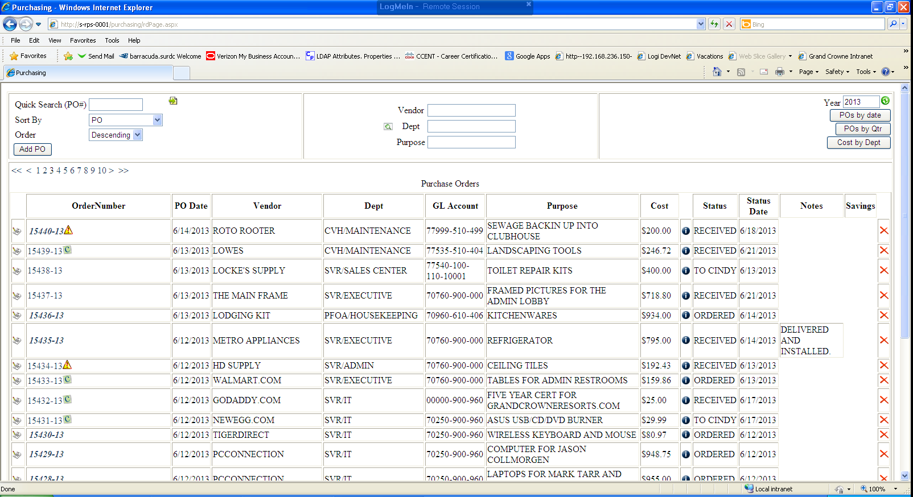

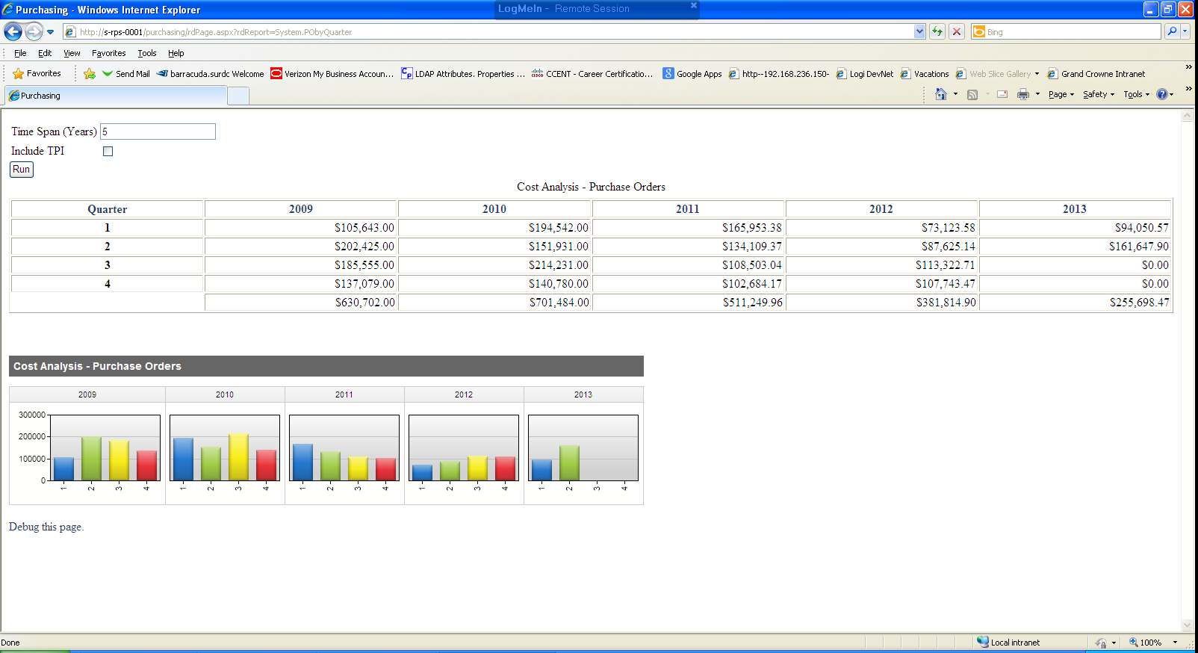

USE [Purchasing]
GO
/****** Object: StoredProcedure [dbo].[sp_AddEditPOAuto] Script Date: 06/23/2013 11:43:24 ******/
SET ANSI_NULLS ON
GO
SET QUOTED_IDENTIFIER ON
GO
-- =============================================
-- Author: Alicia Loughnane
-- Create date: 01/04/2012
-- Description: Add or Edit Purchase Order Purchasing App in Logi Info Studio
-- =============================================
ALTER PROCEDURE [dbo].[sp_AddEditPOAuto] (@inpPOID int, @inpPO varchar(20), @inpLink varchar(100), @inpDate Date, @inpVendor varchar(100), @inpDept varchar(100),
@inpGLAccount varchar(100), @inpPurpose varchar(50), @inpCost money, @inpNotes varchar(max),
@inpSavings money, @inpCreditCard tinyint, @inpEmergencyPO tinyint, @inpTPI tinyint, @inpMode varchar(5), @inpCreatedBy varchar(50))
AS
BEGIN
-- SET NOCOUNT ON added to prevent extra result sets from
-- interfering with SELECT statements.
SET NOCOUNT ON;

declare @NewLink varchar(100)
declare @inpNewPO varchar(20)
declare @Seed as varchar(15)

--Purchasing Scan/2011 Purchase Order Scans/January 2011/11284-11.pdf

set @NewLink = rtrim(SUBSTRING(@inpLink,
CASE WHEN Charindex('Purchasing Scan/',@inpLink)>0
THEN Charindex('Purchasing Scan/',@inpLink)+16
ELSE 1
END, 100)
)

set @inpNewPO = '-' + RIGHT(Year(getdate()),2)

If @inpMode = 'Add'
BEGIN
insert into PurchaseOrders (PO,LINK, [DATE], VENDOR, DEPT,
GLACCOUNT, PURPOSE, COST, NOTES, SAVINGS, CREDITCARD, EMERGENCYPO, TPI, CREATEDBY)

Values(Null,Replace(@NewLink,'\','/'), @inpDate, @inpVendor, @inpDept,
@inpGLAccount, Replace(@inpPurpose,'&',' and '), @inpCost, Replace(@inpNotes,'&',' and '),
@inpSavings, ISNULL(@inpCreditCard,0), ISNULL(@inpEmergencyPO,0), @inpTPI,@inpCreatedBy)

Set @Seed = CAST(@@IDENTITY as Varchar(15))
Set @inpNewPO = CASE WHEN Isnull(@inpEmergencyPO,0) = 1
THEN 'E'
ELSE ''
END
+rtrim(@Seed) + @inpNewPO

Update PurchaseOrders
Set PO = @inpNewPO
Where POID = @@IDENTITY

insert into PODetails (PO, [Status], StatusDate)
Values (@inpNewPO, 'CREATED', GETDATE())

END

IF @inpMode = 'Edit'
BEGIN

Declare @editPO as varchar(20)
Set @editPO =CASE WHEN ISNULL(@inpEmergencyPO,0) = 0
And left(@inpPO,1) = 'E'
THEN Replace(@inpPO,'E','')

ELSE Case When ISNULL(@inpEmergencyPO,0) = 1
And LEFT (@inpPO,1) <>'E'
Then 'E' + @inpPO

ELSE @inpPO
End END
Update PurchaseOrders
Set LINK = Replace(@NewLink,'\','/'),
VENDOR = @inpVendor ,
DEPT = @inpDept ,
GLACCOUNT = @inpGLAccount ,
PURPOSE = Replace(@inpPurpose,'&',' and ') ,
COST = @inpCost ,
[DATE] = @inpDate ,
NOTES = @inpNotes ,
SAVINGS = @inpSavings,
CREDITCARD = @inpCreditCard,
EMERGENCYPO = @inpEmergencyPO,
TPI = @inpTPI
Where POID = @inpPOID
END

END

USE [Purchasing]
GO
/****** Object: StoredProcedure [dbo].[sp_Report_QtrCosts] Script Date: 06/23/2013 11:40:09 ******/
SET ANSI_NULLS ON
GO
SET QUOTED_IDENTIFIER ON
GO
-- =============================================
-- Author: Alicia Loughnane
-- Create date: 01/30/2012
-- Description: Calculate Quartely Costs
-- =============================================
ALTER PROCEDURE [dbo].[sp_Report_QtrCosts] (@inpTimeSpan int, @inpIncludeTPI tinyint)
AS
BEGIN
-- SET NOCOUNT ON added to prevent extra result sets from
-- interfering with SELECT statements.
SET NOCOUNT ON;

Declare @YearCounter int = 1
Declare @QuarterCounter int = 1
Declare @QuarterTot money
Declare @Year int

Create table #QuarterTotals (Year int, QuarterCounter int, QuarterTot money)

Set @Year = YEAR(Getdate()) - @inpTimeSpan +1

While @Year <= YEAR(Getdate())
Begin
While @QuarterCounter <=4
BEGIN
Set @QuarterTot = (Select SUM(Cost)
From PurchaseOrders
Where YEAR([Date]) = @Year
And DATEPART(q,[DATE]) = @QuarterCounter
And ISNULL(TPI,0)=
Case When isnull (@inpIncludeTPI,0) = 0
Then 0
Else ISNULL(TPI,0)
END
)

Insert into #QuarterTotals ([Year],QuarterCounter, QuarterTot)
Values ( @Year,@QuarterCounter,Cast(@QuarterTot as money))

Set @QuarterCounter = @QuarterCounter + 1
End
Set @QuarterCounter = 1
Set @Year = @Year + 1
END
Select * From #QuarterTotals
END
USE [Purchasing]
GO
/****** Object: StoredProcedure [dbo].[sp_Report_POData] Script Date: 06/23/2013 11:39:29 ******/
SET ANSI_NULLS ON
GO
SET QUOTED_IDENTIFIER ON
GO
-- =============================================
-- Author: Alicia Loughnane
-- Create date: 8/22/2012
-- Description: Pull Data for POs/ Purchasing program in Logi
-- =============================================
ALTER PROCEDURE [dbo].[sp_Report_POData] (@inpSortOrder varchar (10), @inpSortBy varchar(25), @findPO varchar(15), @searchVENDOR varchar(50), @searchDEPT varchar(50), @searchPURPOSE varchar(50),@inpYear int)

AS
BEGIN
-- SET NOCOUNT ON added to prevent extra result sets from
-- interfering with SELECT statements.
SET NOCOUNT ON;

Declare @PO varchar(15),
@Vendor varchar(50),
@Dept varchar(50),
@Purpose varchar(50)

Set @PO = @findPO
Set @Vendor = @searchVENDOR
Set @Dept = @searchDEPT
Set @Purpose = @searchPURPOSE

if @PO = ''
Begin
Set @PO = NULL
End

if @Vendor = ''
Begin
Set @Vendor = NULL
End

if @Dept = ''
Begin
Set @Dept = NULL
End

if @Purpose = ''
Begin
Set @Purpose = NULL
End
if @inpSortOrder = 'Descending'
Begin

SELECT PO, POSort, LINK, VENDORID, VENDOR, DEPT, GLACCOUNT,
PURPOSE, COST, [DATE], NOTES, SAVINGS, CREDITCARD, STATUSDATE,
[STATUS], POID, EMERGENCYPO, CREATEDBY, TPI

FROM dbo.POs_v AS PO

Where YEAR([DATE]) = @inpYear
and (@PO is null or Charindex(COALESCE(@PO,PO),PO)>0)
and (@Vendor is null or Charindex(COALESCE(@Vendor,VENDOR),VENDOR)>0)
and (@Dept is null or Charindex(COALESCE(@Dept,DEPT),DEPT)>0)
and (@Purpose is null or Charindex(COALESCE(@Purpose,PURPOSE),PURPOSE)>0)

Order By
CASE WHEN @inpSortBy = 'DEPT' THEN DEPT END DESC,
CASE WHEN @inpSortBy = 'PO' THEN POSort END DESC,
CASE WHEN @inpSortBy = 'VENDOR' THEN VENDOR END DESC,
CASE WHEN @inpSortBy = 'PURPOSE' THEN PURPOSE END DESC,
CASE WHEN @inpSortBy = 'CREDITCARD' THEN CREDITCARD END DESC,
CASE WHEN @inpSortBy = 'STATUS' THEN STATUS END DESC,
CASE WHEN @inpSortBy = 'DATE' THEN [DATE] END DESC,
CASE WHEN @inpSortBy = 'EMERGENCYPO' THEN EMERGENCYPO END DESC

End

if @inpSortOrder = 'Ascending'
Begin

SELECT PO, POSort, LINK, VENDORID, VENDOR, DEPT, GLACCOUNT,
PURPOSE, COST, [DATE], NOTES, SAVINGS, CREDITCARD, STATUSDATE,
[STATUS], POID, EMERGENCYPO, CREATEDBY, TPI

FROM dbo.POs_v AS PO

Where YEAR([DATE]) = @inpYear
and (@PO is null or Charindex(COALESCE(@PO,PO),PO)>0)
and (@Vendor is null or Charindex(COALESCE(@Vendor,VENDOR),VENDOR)>0)
and (@Dept is null or Charindex(COALESCE(@Dept,DEPT),DEPT)>0)
and (@Purpose is null or Charindex(COALESCE(@Purpose,PURPOSE),PURPOSE)>0)

Order By
CASE WHEN @inpSortBy = 'DEPT' THEN DEPT END,
CASE WHEN @inpSortBy = 'PO' THEN POSort END,
CASE WHEN @inpSortBy = 'VENDOR' THEN VENDOR END,
CASE WHEN @inpSortBy = 'PURPOSE' THEN PURPOSE END,
CASE WHEN @inpSortBy = 'CREDITCARD' THEN CREDITCARD END,
CASE WHEN @inpSortBy = 'STATUS' THEN STATUS END,
CASE WHEN @inpSortBy = 'DATE' THEN [DATE] END,
CASE WHEN @inpSortBy = 'EMERGENCYPO' THEN EMERGENCYPO END

End

Select @inpSortOrder as SortOrder, @inpSortBy as Sortby
END
USE [TSWDATA_ClientCustom]
GO
/****** Object: StoredProcedure [dbo].[sp_AvailableInventory] Script Date: 06/23/2013 11:31:52 ******/
SET ANSI_NULLS ON
GO
SET QUOTED_IDENTIFIER ON
GO
-- =============================================
-- Author: Alicia Loughnane
-- Create date: 01/09/2013
-- Description: Pull current available inventory for Available Inventory report in TimeShareWare Logi App
-- =============================================
ALTER PROCEDURE [dbo].[sp_AvailableInventory](@inpSiteID int)
AS
BEGIN
-- SET NOCOUNT ON added to prevent extra result sets from
-- interfering with SELECT statements.
SET NOCOUNT ON;

Select SiteID, [Week], Season, User2 as Building, Reverse(replace(left(Reverse(user4),charindex('-',Reverse(User4))),'-','')) as RoomNum,
Isnull(User1,'') as Unit,
--Case When isnull(User1,'')='' then User3 else User1 end as Unit,
Case When User1 = 'A' then 'A' else '' end as UnitA,
Case When User1 = 'B' then 'B' else '' end as UnitB,
Case When User1 = 'C' then 'C' else '' end as UnitC,
Case When User3 <>'ST' then User3 else '' end as Other,
Case When User1 = 'A' then Count(SalesInventoryID) else 0 end as ATot,
Case When User1 = 'B' then Count(SalesInventoryID) else 0 end as BTot,
Case When User1 = 'C' then Count(SalesInventoryID) else 0 end as CTot,
Case When User3 = 'PH' then count(SalesInventoryID) else 0 end as PHTot,
Case When User3 = 'RS' then count(SalesInventoryID) else 0 end as RSTot,
Case When User3 = 'ST' and User1 is null then count(SalesInventoryID) else 0 end as OtherTot,
Frequency,
Case When Frequency = 'Odd' Then Count(SalesInventoryID) Else 0 End as OddCount,
Case When Frequency = 'Even' Then Count(SalesInventoryID) Else 0 End as EvenCount,
User3, RoomNumber, RoomType,
Case When Charindex('1P',RoomType)+ Charindex('1B',RoomType)>0 then 1 else
Case When Charindex('2B',RoomType)>0 then 2 else
Case When Charindex('3B',RoomType)>0 then 3 else
Case When Charindex('4B',RoomType)>0 then 4 else

0 End End End End as Beds,
OddEvenSalePrice, BothSalePrice, PointValue,
COUNT(SalesInventoryID) as FrequencyCount,
ROW_NUMBER() Over(PARTITION BY Cast([Week] as varchar(2))+User2+RoomNumber ORDER BY Count(SalesInventoryID)) as RowNum

into #UnitTemp
From t_SalesInventory Inv
Where
isnull(soldInventoryID,0) = 0
and InventoryStatus = 'Available'
and InventoryDay = 1
and SiteID = @inpSiteID
--and Season = 'Yellow'
--and User2 = 2 --Building

Group by SiteID, [Week],Season, User2, Reverse(replace(left(Reverse(user4),charindex('-',Reverse(User4))),'-','')),
User1, Frequency, User3, RoomNumber, RoomType, OddEvenSalePrice, BothSalePrice, PointValue

Order by SiteID, [Week],Season, User2, Reverse(replace(left(Reverse(user4),charindex('-',Reverse(User4))),'-','')),
User1, Count(SalesInventoryID),Frequency, User3, RoomNumber, RoomType, OddEvenSalePrice, BothSalePrice, PointValue

--***************************************************
--Check temp table
--Select 'UnitTemp' as TableName,* from #UnitTemp
--***************************************************

--Combine Frequencies

Select SiteID,[Week],Season,Building,RoomNum,Unit,UnitA,UnitB,UnitC,Other,
Max(ATot) as ATot,Max(BTot) as BTot,Max(CTot) as CTot,Max(PHTot) as PHTot,Max(RSTot) as RSTot,Max(OtherTot) as OtherTot,
Sum(Beds) as BedTotal,
Case when Max(OddCount)+ Max(EvenCount) =2
Then 'Annual'
Else Max(Frequency)
End as Frequency,
Case when Max(OddCount)+ Max(EvenCount) =2
Then Max(OddCount)
Else 0
End as AnnualTot,
Case When Max(OddCount)+ Max(EvenCount) <2
Then Max(OddCount)
Else 0
End as OddTot,
Case When Max(OddCount)+ Max(EvenCount) <2
Then Max(EvenCount)
Else 0
End as EvenTot,
Max(PointValue) as PointValueTot,
Case When Max(OddCount)+Max(EvenCount)<2
Then Max(OddEvenSalePrice)
else Max(BothSalePrice)
End as SalePrice --Odd or Even
Into #CombinedFrequency
From #UnitTemp

Group by SiteID,[Week],Season,Building,RoomNum,Unit,UnitA,UnitB,UnitC,Other

--***********************************************************************
--Check Table
--Select * from #CombinedFrequency
--***********************************************************************

--Combine Units ***Union Statement!!****
--Now look at the grouped results and exclude AC Units. We don't want to sell AC Units.

Select SiteID,[Week],Season,Building,RoomNum,
Case When Max(UnitB) <> '' Then Max(UnitA)+Max(UnitB)+Max(UnitC)+' '+Max(Other) else Max(Unit)+' '+Max(Other) End as Units,
Case When Frequency = 'Annual'
Then sum(BedTotal)/2
Else Sum(BedTotal)
End as Beds,
Frequency,
Case When Sum(AnnualTot)>0
Then 1
Else 0
End as AnnualTot,
Case When Sum(EvenTot)>0
Then 1
Else 0
End as EvenTot,
Case When Sum(OddTot)>0
Then 1
Else 0
End as OddTot,
Sum(PointValueTot) as PointValue, -- Use max on Frequency but sum on units
Sum(SalePrice) as SalePrice -- Sales prices are approximate since we discount on combined units.
Into #CombinedUnits
From #CombinedFrequency

Group by SiteID,[Week],Season,Building,RoomNum,Frequency
--,RoomType
Having Max(UnitA)+Max(UnitB)+Max(UnitC) <> 'AC'

Union --Now add in the AC Units - Group by Unit so it doesn't combine the ACs. We want those kept seperate.

Select SiteID,[Week],Season,Building,RoomNum,
rtrim(Max(Unit)+' '+Max(Other)) as Units,
Case When Frequency = 'Annual'
Then sum(BedTotal)/2
Else Sum(BedTotal)
End as Beds,
Frequency,
Case When Sum(AnnualTot)>0
Then 1
Else 0
End as AnnualTot,
Case When Sum(EvenTot)>0
Then 1
Else 0
End as EvenTot,
Case When Sum(OddTot)>0
Then 1
Else 0
End as OddTot,
Sum(PointValueTot) as PointValue, -- Use max on Frequency but sum on units
Sum(SalePrice) as SalePrice -- Sales prices are approximate since we discount on combined units.
From #CombinedFrequency

Group by SiteID,[Week],Season,Building,RoomNum,Frequency,Unit
Having Max(UnitA)+Max(UnitB)+Max(UnitC) = 'AC'

--*************************************************************
--Look at CombinedUnits
--Select * from #CombinedUnits Order by Units,RoomNum
--*************************************************************

--Total Table

Select SiteID, [Week], Season, Building, Units,
Replace(Replace(Cast(Beds as varchar(1))+' bdrm '+ Units,'ST',''),'0','') as UnitType, RoomNum, Frequency as Usage,
Sum(AnnualTot+OddTot+EvenTot) as Quantity, Max(SalePrice) as Price, Max(PointValue) as Points
into #FinalInv
From #CombinedUnits
Group by SiteID, [Week],Season,Building, Units, Cast(Beds as varchar(1))+' bdrm '+ Units, RoomNum, Frequency

--Final Table

Select #FinalInv.SiteID, SiteName, Building, Season, UnitType, Usage,
Sum(Quantity) as Quantity, max(Price) as Price, Max(Points) as Points
From #FinalInv
inner join t_site on t_site.SiteID = #FinalInv.SiteID
Group By #FinalInv.SiteID, SiteName, Building, Season, UnitType, Usage

--Clean up
/*drop table dbo.#UnitTemp
drop table dbo.#CombinedUnits
drop table dbo.#CombinedFrequency
drop table dbo.#FinalInv*/

END

